Rollin' with the Facts Multiplication
Skill: Multiplication facts through 12 x 12
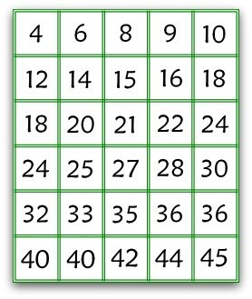
1K+Save
Number of players:2-4
Object of the game: Be the first player to flip over all of his answer cards
Supplies:
- Number cards
- 2 pairs of dice, with different colors
Preparation:
Print the number cards and cut apart
Click to print off Game Cards
To Play:
1. Shuffle all the number cards and pass them out so that each player has the same number of cards. Players place the cards face up in front of them.
2. Players roll the 4 dice to decide who goes first. The player with the lowest total starts.
3. The first player rolls all 4 dice. He adds dice with the same color together to obtain factors. Then he multiplies the two factors. Say he rolls a 6, 3, 5 and a 2…

Example:  6 + 3 = 9 | Example:  5 + 2 = 7
Math Fact 9 x 7 = 63
4. He writes the factors, a multiplication fact, and the answer on his paper. He reads this equation to the other players. If they agree with his answer, the player looks at the cards in front of him. If he has the 63, he flips it over. Then he rolls again. All players get two rolls on each turn, whether or not they flip a card.
5. If at any time someone disagrees with the player’s answer, she may challenge the answer. She checks it with the calculator. If challenger is right, the player’s turn is over, and the challenger wins an extra turn.
6. Players continue to take turns rolling the dice, adding to find the factors, and multiplying the factors to find the products, and writing the math sentence.
7. If a player has 3 turns in a row without a flip, he has the option of a “free flip.” He chooses any unturned card and writes a multiplication sentence on his paper that uses the number as a product. For example, if he wants to “flip” the number 132, he writes on his paper 11 x 12 = 132 and reads this to the other players. A player may not roll on a “free flip” turn.
8. Play continues until one player has flipped over all of his cards. He is the winner of the game.
Have Fun!!!

