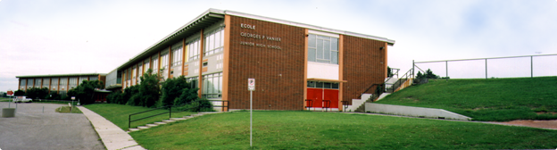

## Invitation Information

509 – 32 Avenue NE

Calgary, Alberta

t | 403-777-7460

The Open House for Georges P. Vanier School will take place from 6:00-8:00pm on Thursday January 25, 2018. If you are interested in learning more about the following programs, we encourage you to attend with your child. Student representatives, teachers, and administration will be available to answer your questions.

Regular English Program (Grades 7-9)

Late French Immersion Program (Grades7-9)

Continuing French Immersion Program (Grades 7-9)

CBE – Learning & Literacy Program

### Agenda

* 6:00-6:15 – Band performance
* 6:15-6:45 – Presentation about our school
* 6:45:-7:30 – Exploration time
* 7:15-7:45 – Late French Immersion presentation

#### Questions

Date

**Thursday Jan 25, 2018**

Time

**6:00-8:00PM**

Location

**Georges P. Vanier School**

**509 – 32 ave NE**

Please email georgespvanier@cbe.ab.ca if you have any questions.